**Surface tension**

**definition**

Surface tension is the property of a liquid, by virtue of which its free surface at rest behaves like an elastic skin or a stretched rubber membrane, with a tendency to contract so as to occupy minimum surface area. This property is caused by cohesion of molecules and is responsible for much of the behaviors of liquids

The property of surface tension is revealed, for example, by the ability of some objects to float on the surface of water, even though they are denser than water. Surface tension is also seen in the ability of some insects, such as water striders, and even reptiles like basilisk, to run on the water’s surface

The theory behind surface tension:

Surface tension has been well- explained by the molecular theory of matter. According to this theory, cohesive forces among liquid molecules are responsible for the phenomenon of surface tension. The molecules well inside the liquid are attracted equally in all directions by the other molecules. The molecules on the surface experience an inward pull.

So, a network is formed against the inward pull, in order to move a molecule to the liquid surface. It results in a greater potential energy on surface molecules. In order to attain minimum potential energy and hence stable equilibrium, the free surface of the liquid tends to have the minimum surface area and thereby it behaves like a stretched membrane.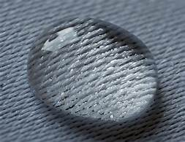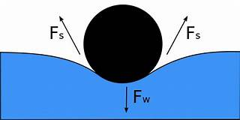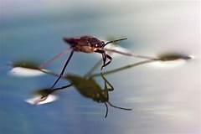

Studying water shows several effects of surface tension:

**A**. Rain water forms beads on the surface of a waxy surface, such as a leaf. Water adheres weakly to wax and strongly to itself, so water clusters into drops. Surface tension gives them their near-spherical shape, because a sphere has the smallest possible surface area to volume ratio.

**B**. Formation of [drops](https://simple.wikipedia.org/w/index.php?title=Drop_(liquid)&action=edit&redlink=1) occurs when a mass of liquid is stretched. The animation shows water adhering to the faucet gaining mass until it is stretched to a point where the surface tension can no longer bind it to the faucet. It then separates and surface tension forms the drop into a sphere. If a stream of water were running from the faucet, the stream would break up into drops during its fall. Gravity stretches the stream, then surface tension pinches it into spheres.[[2]](https://simple.wikipedia.org/wiki/Surface_tension#cite_note-MIT5-3)

**C**. Objects denser than water still float when the object is nonwettable and its weight is small enough to be borne by the forces arising from surface tension.[[1]](https://simple.wikipedia.org/wiki/Surface_tension#cite_note-white-1) For example, [water striders](https://simple.wikipedia.org/wiki/Gerridae) use surface tension to walk on the surface of a pond. The surface of the water behaves like an elastic film: the insect's feet cause indentations in the water's surface, increasing its surface area.[[3]](https://simple.wikipedia.org/wiki/Surface_tension#cite_note-MIT3-4)

**D**. Separation of oil and water (in this case, water and liquid wax) is caused by a tension in the surface between dissimilar liquids. This type of surface tension is called "interface tension", but its physics are the same

**Surface tension determines the efficiency of detergent formulation:**

So many new surfactants are made everyday for making detergents and soap better. Different formulations to help in cleaning clothes, hard surfaces or our bodies rely on surface tension to get the correct wettability. The high surface tension of water makes it a relatively poor cleaning detergent. By increasing the temperature of water (as is often done when washing clothes or dishes), the cleaning efficiency increases slightly as surface tension decreases. The effect of temperature alone is not enough to make water a good detergent and thus addition of surfactants is needed. [Surfactants](https://www.biolinscientific.com/surface-cleanliness/surfactants) are surface active molecules that adsorb to the interface decreasing the surface tension. Surface tensions are routinely measured when detergent formulations are developed.

Defect-free coatings by surface tension optimization of paints

The basic requirement for paints is that it can form a uniform, defect-free coating on a surface. Many of the surface defects like levelling and orange peel and craters or fish eyes, are related to surface tension and can be solved by fine-tuning it. To affect the surface tension of the paint, small amounts of surfactants need to be added. As lower surface tension can be related to better wetting of the substrate, relatively low surface tensions of paints are needed. However, too low of a surface tension can also cause levelling issues. Due to this, a surface tension balance need to be achieved to have defect free coating.

<https://blog.biolinscientific.com/why-is-surface-tension-important>